Vel Tech Rangarajan Dr. Sagunthala R&D Institute of Science and Technology (Deemed to be University Estd. u/s 3 of UGC Act, 1956)


School of Computing
B.Tech. – Computer Science and Engineering
VTR UGE2021- (CBCS)

Academic Year: 2025–2026
SDG 4: Quality Education Course Code : 10211CS207
Course Name : Database Management Systems Slot No : S7-L1

DBMS PROJECT REPORT

Title: LIBRARYMANGEMENT DATABASE

Submitted by:

VTUNO | REGISTER NUMBER | STUDENT NAME
VTU29710 | 24UECS1383 | SK.AFRID
VTU29551 | 24UECS0366 | Y.MAHENDRA
VTU29748 | 24UECS1234 | K.GOPI CHAND
VTU29603 | 24UECS1189 | D.AKASH
VTU29563 | 24UECS0562 | G.ASHOK

Under the guidance of:
Dr. T.Ravi
Associate Professor

pg. 1

INDEX
- Introduction
- Problem Statement
PAGE
…………………………………………… 3
…………………………………………… 4

- Objectives 5
- System Requirements 6
- System Analysis and Design 6
- ER Diagram (Conceptual Design) 7
- Schema Design (Oracle) 9
- Normalization 13
- Implementation (SQL Queries) 13
- Input and Output 14
- Integration with MongoDB (NoSQL) 15
- Results and Discussion 19
- Conclusion 20
- References 20

- Introduction

In the modern digital era, libraries are transitioning from traditional manual systems to automated platforms to efficiently manage their growing collections, memberships, and services. As educational institutions and public libraries expand, the management of books, journals, digital media, and user records becomes increasingly complex. A reliable, consistent, and scalable Library Management Database is therefore essential to ensure smooth and accurate handling of library operations.

Traditional library systems often rely on manual record keeping or standalone software that suffers from limitations such as data redundancy, loss of information, slow retrieval speed, and human errors. These challenges lead to inefficient resource utilization, difficulty in tracking issued and returned books, and poor user experience. To overcome these issues, the Library Management Database System introduces a structured, relational database solution that ensures ACID compliance (Atomicity, Consistency, Isolation, and Durability), enabling accurate, secure, and efficient data management for large-scale libraries.

The primary objective of this system is to provide a centralized digital platform to manage all core library functions, including cataloging, book issuance, member registration, fine calculation, and report generation. Each operation—such as issuing or returning a book—is executed as an atomic transaction, ensuring that no inconsistency or duplication occurs within the database. This approach guarantees that all book and member records remain synchronized and up to date.

To achieve these goals, the system employs a relational database model such as MySQL or PostgreSQL, which supports strong consistency, data normalization, and efficient query performance. These databases are capable of handling multiple concurrent transactions while maintaining data integrity. Additionally, for managing unstructured or semi-structured data such as digital resources, images, or scanned documents, a hybrid integration with a NoSQL database like MongoDB can be incorporated to enhance scalability and flexibility.

Another key aspect of this system is data normalization. The database schema is carefully designed and normalized up to Third Normal Form (3NF) to eliminate redundancy, minimize anomalies, and optimize query execution. Entities such as Books, Members, Staff, Issues, Returns, and Fines are interconnected through well-defined relationships, allowing for efficient data organization and retrieval.
n essence, the Library Management Database System offers a modern, secure, and scalable solution for digital library operations. It ensures that both librarians and members benefit from a fast, accurate, and transparent system that simplifies everyday tasks such as searching, borrowing, and tracking library materials. By leveraging relational database principles and optional NoSQL integration, this system provides a powerful and reliable platform for managing library resources in academic and public environments.

- Problem Statement

In many educational institutions and public libraries, traditional methods of managing books, members, and transactions still rely heavily on manual processes or outdated software systems. These approaches often result in inefficiencies such as data redundancy, loss of records, inaccurate tracking of issued books, and difficulty in generating timely reports. As the volume of books and the number of library users increase, maintaining accuracy and consistency across records becomes a major challenge

Manual systems also make it difficult to monitor book availability, calculate fines, and update book inventories in real time. Furthermore, searching for books or user information can be time-consuming and prone to errors. Lack of data security and limited accessibility further hinder the effectiveness of library operations, particularly in large institutions where multiple staff members need to access and update records simultaneously.

Existing software-based solutions may not provide the necessary scalability, normalization, or ACID compliance required for handling large datasets efficiently. They often fail to support seamless integration with online catalogues, digital resources, or cloud-based services, limiting the library’s ability to modernize and expand its services.

Existing software-based solutions may not provide the necessary scalability, normalization, or ACID compliance required for handling large datasets efficiently. They often fail to support seamless integration with online catalogues, digital resources, or cloud-based services, limiting the library’s ability to modernize and expand its services.

Objectives

  - To automate all library activities such as book issue, return, and member management.
  - To maintain accurate and up-to-date records of books, members, and transactions.

  - To reduce manual work, human errors, and paperwork in daily operations.

  - To eliminate data redundancy by applying proper database normalization.

  - To provide fast and easy searching of books, authors, and members.

  - To track the availability and status of books in real time.

  - To calculate fines automatically for overdue books.

  - To generate useful reports such as issued books, due dates, and member details.

  - To ensure data security and restrict unauthorized access.

  - To allow multiple users to access and update the system simultaneously.

  - To provide a user-friendly and efficient interface for librarians and members.

System Requirements

Hardware Requirements:

- Processor: Intel i5 or higher
- RAM: 8 GB or more
- Hard Disk: 250 GB

Software Requirements:

- OS: Windows 10 or Linux
- Database: Oracle 12c or above
- Front-End: Java / Web Interface
- NoSQL: MongoDB 6.0
- Tools: Oracle SQL Developer, MongoDB Compass

System Analysis and Design

The system identifies the main entities and their relationships. Major entities include:
  - Student
  - Registration
  - Login
  - Admin
  - Book Transaction
  - Library
  - Online Library System

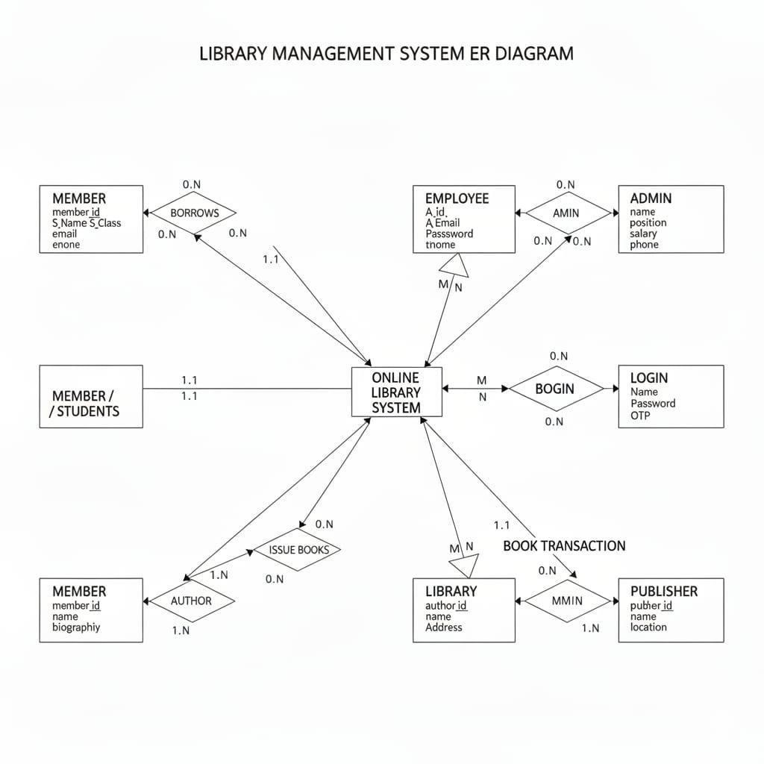

Relationships:

    - One member can have one registration
    - One admin can validate many
    - One member can have many books
    - One library can issue many books through the system
    - One admin can manage one or more system.
    - Figure: ER Diagram Entities and Attributes
- Student (Student_ID, Student_Name, Student_Class)
- Registration (User name, Address, Phone, Email,Password)
- Login (Email, Password, OTP)
- Admin (Admin_ Password, Admin_Email,,Admin_id)
- Book Transation (Reserve data, Return date,Quantity)
- Library (Name,Address)

Relationships
- Member/Students – Registration → creates account (1:1)
- .Registration – Admin/Librarian → validates user (N:1)
- Member/Students – Book Transaction → reserves or returns books (1:N)
- .Book Transaction – Online Library System → provides book (N:1)
- .Admin/Librarian – Online Library System → manages system (M:N)
- .Online Library System – Library → issues books through library (1:N)

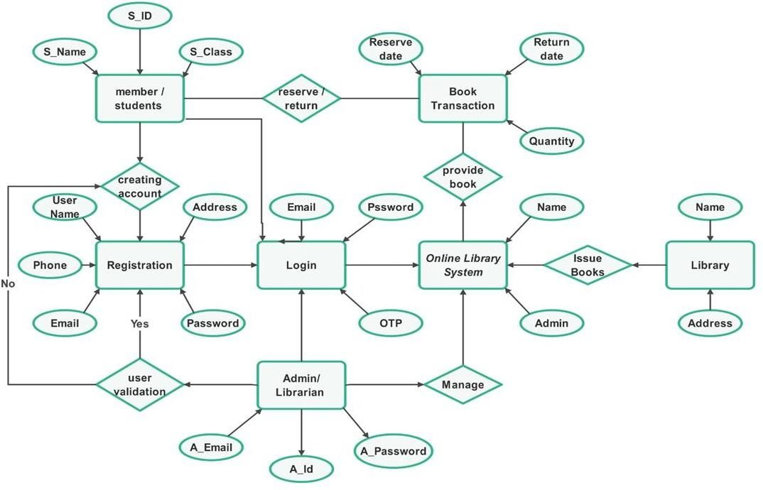

Schema Design (Oracle)

SQL> CREATE TABLE Students ( S_ID INT PRIMARY KEY, S_Name VARCHAR(100), S_Class VARCHAR(50)
);
Output:

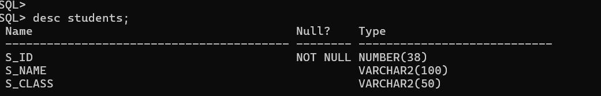

SQL>CREATE TABLE Registration ( Reg_ID INT PRIMARY KEY AUTO_INCREMENT,
UserName VARCHAR(100),
Phone VARCHAR(15),
Email VARCHAR(100) UNIQUE,
Password VARCHAR(100), Address VARCHAR(255), S_ID INT,
FOREIGN KEY (S_ID) REFERENCES
Member_Students(S_ID)); Output:

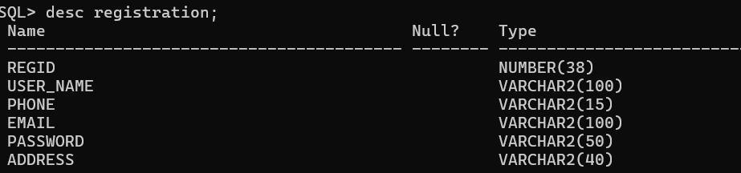

SQL>CREATE TABLE
Admin_Librarian (
A_Id INT PRIMARY KEY, A_Email VARCHAR(100),
A_Password VARCHAR(100)); Output:
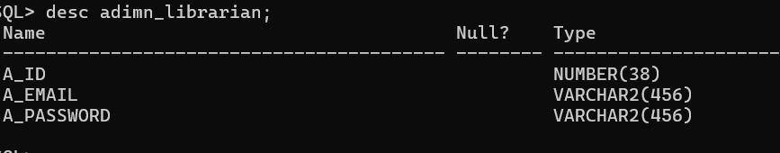

SQL>CREATE TABLE Login (
Login_ID INT,
Email VARCHAR(100),
Password VARCHAR(100), Registration(Reg_ID));

);

Output:

SQL>CREATE TABLE Library ( Lib_ID INT PRIMARY KEY AUTO_INCREMENT,
Name VARCHAR(100), Address VARCHAR(255));

Output:

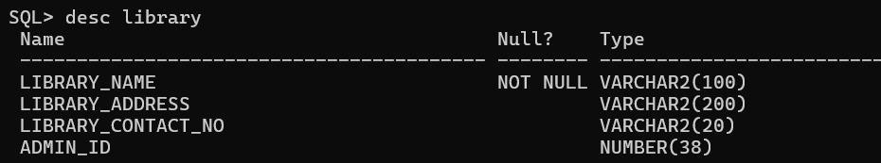

SQL>CREATE TABLE Online_Library_System ( System_ID INT PRIMARY KEY AUTO_INCREMENT,,
OTP VARCHAR(10), A_Id INT,
Lib_ID INT, FOREIGN KEY (A_Id) REFERENCES Admin_Librarian(A_Id), FOREIGN KEY (Lib_ID) REFERENCES Library(Lib_ID));

Output:

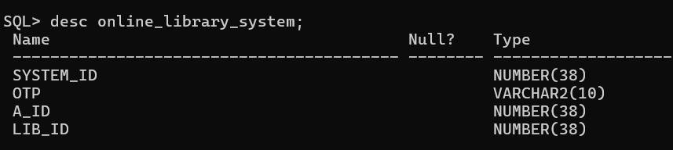

Normalization

Step 1: First Normal Form (1NF)

All attributes in the system are atomic and contain single values.
Tables such as Member/Students, Registration, Login, Admin/Librarian, Library, Book_Transaction, and Online_Library_System contain no repeating groups or multivalued attributes.
Hence, all relations are in 1NF.

Step 2: Second Normal Form (2NF)

A table is in 2NF if it is already in 1NF and all non-key attributes are fully dependent on the primary key.
- Member/Students → Primary key: S_ID, attributes S_Name and S_Class depend fully on S_ID.
- Registration → Primary key: Reg_ID, attributes like UserName, Email, Phone, and
Password depend on Reg_ID.
- Admin → Primary key: A_Id, attributes A_Email and A_Password depend on A_Id
- .Library → Primary key: Lib_ID, attributes Name and Address depend on Lib_ID.
- Book_Transaction → Primary key: Transaction_ID, attributes Reserve_Date, Return_Date, and Quantity depend on Transaction_ID.
- Online_Library_System → Primary key: System_ID, attributes OTP, A_Id, and Lib_ID depend on System_ID.
Thus, there are no partial dependencies, and all relations are in 2NF.

I

Step 3: Third Normal Form (3NF)
  - A relation is in 3NF if it is in 2NF and there are no transitive dependencies (non- key attributes depending on other non-key attributes).
  - In all tables, non-key attributes depend only on the primary key:
  - S_Name and S_Class depend on S_ID
  - Email, Password, Phone depend on Reg_ID
  - Reserve_Date, Return_Date, Quantity depend on Transaction_ID
  - A_Email and A_Password depend on A_Id
  - Lib_Name and Lib_Address depend on Lib_ID
  - Result:After normalization, all tables in the Online Library Management System are in Third Normal Form (3NF).This ensures data is well organized, free from redundancy, and maintains data integrity for efficient database operations.
  - No transitive dependencies exist. Hence, all tables are in 3NF.

Result:
After normalization, all tables in the Online Library Management System are in Third Normal Form (3NF).This ensures data is well organized, free from redundancy, and maintains data integrity for efficient database operations.

Implementation (SQL Queries)

INSERT INTO adimn_librarian VALUES (101, 'admin1library.com', 'admin123')
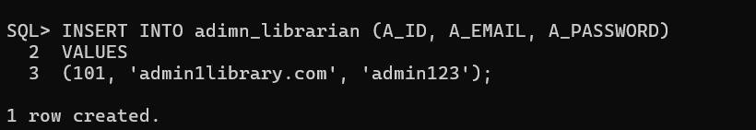

INSERT INTO online_ library_system VALUES( 401, 'OTP1234', 101, 1);
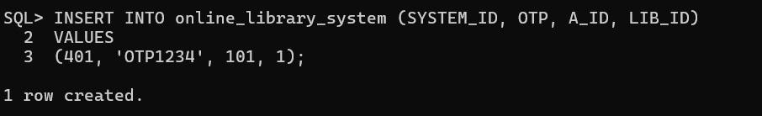

INSERT INTO login VALUES(
301, 'raviexample.com', 'ravi123', 201)

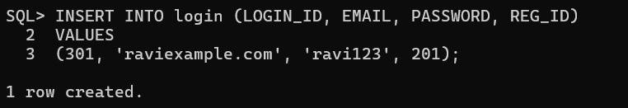

pg. 16

INSERT INTO registration VALUES(201, 'ravi’’,77777777,
'raviexample.com', 'ravi123', 'Hyderabad');
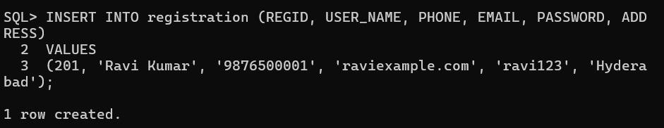

INSERT INTO students VALUES( 501, 'Ravi Kumar', 'B.Tech 3rd Year');
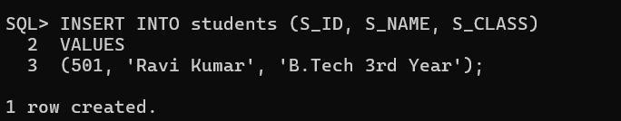

INSERT INTO library (LIBRARY_NAME, LIBRARY_ADDRESS, LIBRARY_CONTACT_NO, ADMIN_ID)VALUES ('Central Library', 'Hyderabad', '9876543210', 101);
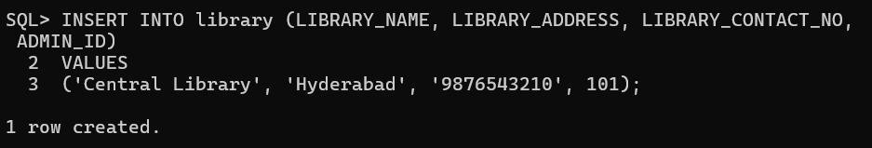

Input and Output
**Sample Input Queries:**

INSERT INTO Student VALUES (102, 'Mary Jane', 'mary@gmail.com',

Insert StudentsINSERT INTO students VALUES (501, 'Ravi Kumar', 'B.Tech 3rd Year'),--
Insert LibraryINSERT INTO library VALUES (1, 'Central Library',
'Hyderabad', '9876543210', 101);-- Insert Book TransactionsINSERT
INTO book_transaction VALUES (701, 501, 1, '2025-10-25', '2025-11-
05', 2),

**simple out put query and result:
** query

SELECT
s.S_NAME AS Student_Name, l.LIBRARY_NAME AS Library_Name,
b.RESERVE_DATE, b.RETURN_DATE
FROM students
sJOIN book_transaction b ON s.S_ID = b.S_IDJOIN library l ON b.LIB_ID = l.LIBRARY_ID;

Student_Name Library_Name Reserve_Date Return_Date ra

'IT');
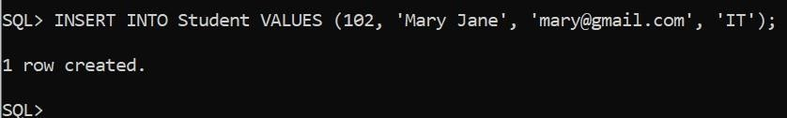
INSERT INTO Course VALUES (302, 'Web Programming', 3, 201);
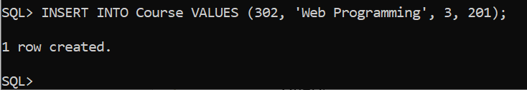

**Sample Output Query and Result:** Query:
SELECT s.Student_Name, c.Course_Name FROM Student s JOIN Enrollment e ON s.Student_ID = e.Student_ID JOIN Course c ON e.Course_ID = c.Course_ID;

Output:

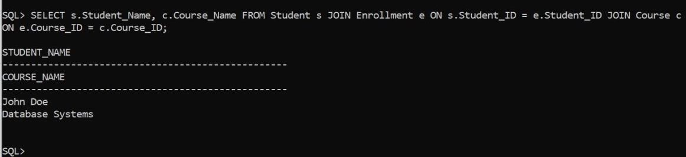

Integration with MongoDB (NoSQL)

MongoDB is a NoSQL, document-oriented database used to store large volumes of unstructured or semi-structured data. In contrast to relational databases like Oracle, MongoDB stores data in JSON-like documents instead

- Integration with MongoDB (NoSQL)

MongoDB is a NoSQL, document-oriented database used to store large volumes of unstructured or semi-structured data. In contrast to relational databases like Oracle, MongoDB stores data in JSON-like documents instead of rows and columns
This makes it highly flexible, scalable, and efficient for applications that deal with dynamic content, such as library management system
MongoDB stores unstructured data such as lecture videos, PDFs, and feedback threads.
MongoDB Database Structure for the Project Database Name: library management
Collections and Example Documents

- students Collection
{
"_id": 1,
"student_id": "STD101", "student_name": "Ravi Kumar", "student_class": "10A"
}

- Registration Collection
{{ "_id":
1,
"user_name":"john_doe", "address": "123 Main St", "phone": "555-1234",

“email”:john@example.com “password”:”securepass123”
)

- Logins collection{
"_id": 1,
"email": "john@example.com", "password": "securePass123", "otp": "453321"
}
- Admines Collection
{{
"_id": 1,
"admin_id": "ADM201", "admin_email": "admin@library.com", "admin_password": "adminSecurePass"

- book_transaction collection
{
"_id": 1,
"reserve_date": "2025-10-29",
"return_date": "2025-11-10",
"quantity": 2
}

- Inserting a new collection Fetching db.students.insertOne({
"student_id": "STD102", "student_name": "Anjali Mehta", "student_class": "9B"
})
// Output:

{
"acknowledged": true, "insertedId": 2
}
- fetching all book transactions after adatedb.book_transactions.find(
{ reserve_date: { $gte: "2025-10-28" } },

{ reserve_date: 1, return_date: 1, _id: 0 }
)

// Output:

[
{ "reserve_date": "2025-10-29", "return_date": "2025-11-10" },

{ "reserve_date": "2025-10-30", "return_date": "2025-11-15" }

- Updating student class .db.students.updateOne(
{ student_id: "STD101" },
{ $set: { student_class: "11A" } }
)
// Output:
{
"acknowledged": true, "matchedCount": 1,
"modifiedCount": 1
}

- FindingStudentsSubmitting Assignmentsdb.book_transactions.find(
{ quantity: { $gte: 1 } },
{ reserve_date: 1, quantity: 1, _id: 0 }
)
// Output: [
{ "reserve_date": "2025-10-29", "quantity": 2 },
{ "reserve_date": "2025-10-30", "quantity": 1 }
]

Results and Discussion

The design and analysis of the Online Library System database successfully identified the key entities, their attributes, and the relationships between them. The resulting Entity-Relationship (ER) Diagram clearly illustrates how different components of the system such as students, admin, and library interact to manage book transactions efficiently

Conclusion
The developed database design for the Online Library System demonstrates an effective, normalized, and scalable structure for managing library operations. It simplifies key functions such as registration, login, book issue and return, and admin management .By implementing this database, libraries can improve operational efficiency, reduce manual workload, and provide a better digital experience for both students and administrators.
.

References

- Oracle Database Documentation – Oracle Corporation
- MongoDB Official Documentation
- Silberschatz, Korth, Sudarshan – Database System Concepts
- Raghu Ramakrishnan – Database Management Systems

